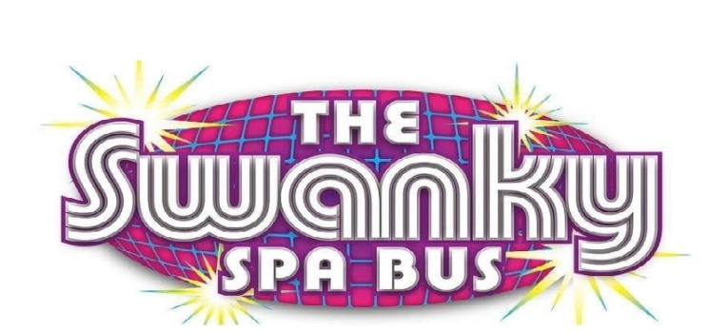

Every child must have a release form filled out and signed and brought to the party.
Photo Release Form for Minors
I give The Swanky Spa Bus and Pamper Us Pretty LLC, permission to use my child’s likeness, image, voice, and/ or appearances as such may be embodied in any pictures, photos, video recordings, digital images, and the like, taken or made on behalf of The Swanky Bus and Pamper Us Pretty LLC, party activities. I agree That The Swanky Spa Bus and Pamper Us Pretty has complete ownership of such pictures, etc., including the entire copyright, and may use them for any purpose consistent with The Swanky Bus and Pamper us Pretty LLC Mobile Spa Parties. These uses include, but are not limited to, reprints, publications, advertisements, social media and any promotional materials in any medium now known or later developed, including the internet. I acknowledge that I will not receive any compensation, etc for the use of such pictures, etc., and hereby release The Swanky Spa Bus and Pamper Us Pretty LLC, from any and all claims which out of are in any way connected with such use. I have read and understood this consent and release.

Makeup Consent Form
The Swanky Spa Bus LLC, requires you the Parent to print and sign this waiver. As part of the Spa experience, age appropriate makeup and spa treatment products will be applied. This includes, but not limited to lip gloss, eye shadow, and blush. Makeup products used are hypoallergenic and makeup applicators are new and disposable. The Swanky Spa Bus has its own line of Gourmet Spa Products especially made for girls called Pamper Us Pretty. Our products are handmade using only the finest quality ingredients from start to finish, every product is made with natural, mild ingredients, and are: 95% or More natural, Gluten Free, Paraben Free & Cruelty Free! I have read and understood this consent and release.

Food Allergy Permission Slip
​Your child will be participating in various activities on the Swanky Spa Bus. Additionally, some of the activities involve food products as part of the experience. We take every precaution on the Swanky Spa Bus to ensure that our girls are safe. The Swanky Spa Bus will not be responsible for any allergic reactions or life threatening incident including death that could occur. Therefore, the Swanky Spa Bus LLC, would appreciate if you would complete and return this consent/permission slip form before your child can participate in any food-related activities. If your child has any known food allergies that may prevent her from participating in these activities, we will provide an alternative option per your request.

1.Parent/Guardian’s signature_____________________________
2.Child’s Name and Age:_________________________________
3.Phone Number:________________________________________
4.Date:________________________________________________
5.Sibling’s Name:________________________________________

